# MS Office Excel (Project 2B)

Hey everyone - welcome back! Hey everyone – welcome back! In my next tutorial, I created a weekly sales summary worksheet. I continued to work with the data for Rosedale Landscape and Garden. Mariam Daly is the Sales Director of the company. She wanted to know the online and in-store sales of products during a one-week period in April.

First, I double clicked on the “Sheet1” tab and typed “Online Sales”. Then, I right clicked, selected “Tab Color”, and chose the second to last color in the first row, “Blue, Accent 5”. I repeated this process for the “Sheet2” tab, but I set the name as “In-Store Sales” with the first color of “Green, Accent 6” instead.

On the “Online Sales” worksheet, I clicked on cell A16, navigated to the “Home” tab, and clicked on the arrow in the lower-right hand corner of the “Number” group. When I clicked on the arrow, I got a “Format Cells” pop-up window.

I clicked on cell A16, the “Online Sales” worksheet, navigated to the “Home” tab, went to the “Number” group, and selected the arrow in the lower right-hand corner. When I clicked on the arrow, I got a “Format Cells” pop-up window. In the drop-down menu for the “Date” category, I selected the “3/14/12” option.

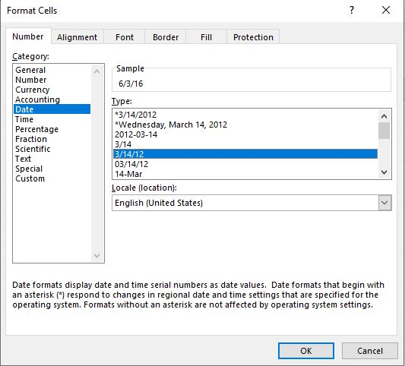

Once I clicked OK, I typed in “6-7-16” in cell A19. Since Excel automatically formats dates with the “m/d/yyyy” format, I clicked on cell A16, navigated to the “Home” tab, went to the “Clipboard” group, selected “Format Painter”, and highlighted cell A19.

In the “Online Sales” worksheet, I clicked cell A1, navigated to the “Home” tab, went to the “Editing” group, selected “Clear”, and chose “Clear Contents”. Then, I pressed “Delete” in cell A2. In cell A1, I typed “Online Sales” and chose “Clear Formats” in the “Editing” group. Next, I repeated the “Clear Formats” step in cell A2. I selected the range from cell A4 to A19, right clicked, and chose “Copy”. In the “In-Store Sales” worksheet, I right clicked and chose the first “Paste” option.

Now, I grouped my two worksheets to edit them together. To do this, I pressed “Ctrl” on the “Online” and “In-Store” Sales worksheets. I selected columns A through G and set their width to 85 pixels. In cell A2, I typed “Week of May 24”, merged, and centered the text across the range A2:G2, then applied the 'Heading 1” cell style. In row 4 I typed in the following text in the following cells:

* E4: Total Rose Sales
* F4: Rose Supply Sales
* G4: Total Sales

I selected the range from A4 to G4, applied the “Heading 3” cell style, center and middle aligned my text and wrapped my text. Next, I clicked on the “In-Store Sales” worksheet to ungroup the worksheets. In the “Online Sales” worksheet, I typed “Rose Plants and Rose Supplies: Weekly Online Sales” in cell A1. Then, I merged and centered the text across the range from A1 to G1 with the “Title” cell style. In the column titled “Rose Supply Sales”, I clicked cell F5. Then in the range from F5 to F11, I typed in the following data for Rose Supply Sales:

* 1926.49
* 1526.03
* 1853.82
* 1922.36
* 1973.73
* 2121.47
* 2025.55

I formatted the values as “Currency” and decreased the number of spots after the decimal point to zero. I followed the same steps to format the “In-Store Sales” worksheet. But my title in cell A1 was “Rose Plants and Rose Supplies: Weekly In-Store Sales” instead. My values in the “Rose Supply Sales” column from F5 to F11 were also different:

* 1626.59
* 1483.69
* 1693.82
* 1778.94
* 1416.37
* 1645.24
* 1493.47

I right clicked the “Online Sales” worksheet and chose “Select All Sheets” to group my worksheets. I clicked cell E5, navigated to the “Home” tab, went to the “Editing” group, and chose “AutoSum”. Then, I used the fill-down tool down vertically from E5 to E11. In cell G5, I typed “=E5+F5”. In cell A12, I typed “Total”. Next, I selected the range from B5 to G12, held down “Alt” and pressed “=”. This entered in the “SUM” in each empty cell. Then, I formatted the ranges from A5 to A12 and B12 to G12 with the “Heading 4” and “Total” cell styles, respectively.

My last step was creating a summary sheet with column sparklines. A summary sheet is a worksheet, where totals from other worksheets are shown and summarized. Sparklines are tiny charts in a single cell that show a trend in data. Before I created the summary sheet, I ungrouped my two worksheets. Then, I right-clicked on the “In-Store” worksheet and selected “New sheet”. I renamed the new worksheet as “Summary” with a “Tab Color” of “Gold, Accent 4”. Then, I highlighted columns A through E and set the width to 110 pixels. In cell A1, I typed “Sales of Rose Plants and Rose Supplies” and merged and centered the title across the range from A1 to E1 with the “Title” cell style. In cell A2, I typed “Week of May 24” and applied the same merge and center format. But this time, I set the cell style to “Heading 1”. In row 4, I entered in the following headings in the respective cells:

* B4: Roses/Rose Supplies
* C4: Rose Sales
* D4: Rose Supply Sales
* E4: Total Sales

For these table headings, I applied the “Heading 3” cell style and “Center Align” and “Middle Align” alignments with text wrapped. In cells A5 and A6, I typed “Online Sales” and “In-Store Sales”, respectively. Now, I’m ready to create formulas that’ll be based off from the online and in-store sales worksheets. In cell C5, I typed “=”, clicked the “Online Sales” worksheet, selected cell E12, and pressed “Enter”. I repeated this step for cell D5. But I chose cell F12 instead. Then, I followed this procedure for the “In-Store Sales” worksheet. In cell A7, I typed “Total”, selected the range from C5 to E6, navigated to the “Home” tab, went to the “Editing” group, and clicked “AutoSum” to calculate the sum for the range. In the “In-Store Sales” worksheet, I clicked on cell B8 and typed “1410.88”. I clicked on cell B5, navigated to the “Insert” tab, went to the “Sparklines” group, and chose “Column”. When I clicked on “Column”, I got a “Create Sparklines” pop-up window. In the “Data Range” box, I typed “C5:D5”. I repeated this step for cell B6. But the difference was that my data range was C6:D6. For the second column sparkline, I navigated to the “Sparkline” tab, went to the “Style” group, and chose “Sparkline Style Accent 4 (no dark or light)” in the third row, the fourth style.

So, this is how I created a weekly sales summary worksheet. Hope this tutorial was helpful and I’ll see you in the next one!